

**REPUBLIC OF CAMEROON**

PEACE-WORK-FATHERLAND

THE UNIVERSITY OF BUEA

P.O Box 63,

Buea, South West Region

Cameroon

**FACULTY OF ENGINEERING AND TECHNOLOGY**

**Dean: Agbor Dieudonne Agbor PhD**

**Vice-Dean : Nde D. Nguti, PhD**

**Faculty Officer : Mme Ekpombang Patience Taku**

Date: 09/06/ 2024

**CEF440 – TASK 5:**

**UI DESIGN AND IMPLEMENTATION FOR A ROAD SIGN ROAD STATE NOTIFICATION APP, SAFEWAKA**

Presented by

**GROUP 4**

|  |  |  |
| --- | --- | --- |
| SN | NAME | MATRICULE NUMBER |
| 1 | DJOUMESSI NGUEFACK IVAN | FE21A174 |
| 2 | NJOYONG GODWILL | FE21A273 |
| 3 | TETUH WIBINAH ENGONWEI | FE21A322 |
| 4 | DJOUMESSI DONGMO RONSARD CARNEGIE | FE21A172 |
| 5 | GATCHUINNE MOMO MURIELLE CYNTHIA | FE21A200 |

**Valery Nkemeni, PhD**

**Course Supervisor**

**Introduction**

Purpose

The purpose of this UI Design and Implementation Report is to document the design process, technical implementation, and deployment of the new user interface for the SAFE WAKA web application. This report serves as a comprehensive record of the project's progress, design decisions, and the final delivered solution. It aims to provide a detailed account of how the UI was conceived, developed, and ultimately deployed to meet the evolving needs of the application's target users.

**Key Use Cases:**

1. **Identification and Interpretation of Road Signs**:

* Users can use the application to quickly identify and understand the meaning of various road signs encountered during their journeys.
* This can help drivers stay informed about traffic regulations, road hazards, and other important information, improving their overall driving experience and compliance with traffic laws.

1. **Real-Time Road Condition Updates**:

* Users can access real-time information about the current state of the roads, including traffic congestion, accidents, weather-related hazards, and road closures.
* This information can assist drivers in making informed decisions about their routes, allowing them to avoid delays, plan alternative paths, and reach their destinations more efficiently.

1. **Personalized Notification and Alerts**:

* Users can customize the application to receive personalized notifications and alerts based on their preferences, such as specific road signs, routes, or geographic areas of interest.
* These alerts can help drivers stay informed about important developments and make timely adjustments to their driving plans, enhancing overall safety and reducing the risk of incidents.

1. **Integration with Navigation Systems**:

* The application's integration with popular navigation systems can provide users with a seamless experience, allowing them to access road sign information and road condition updates directly within their preferred navigation app.
* This integration can enhance the overall driving experience, providing users with a comprehensive set of tools to navigate the road network effectively.

**Design Goals and Principles**

1. **Design Goals**
2. **Ease of Use**: We designed the user interface to be intuitive and user-friendly by employing a minimalist approach, focusing on essential features and information, and minimizing the cognitive load on drivers and commuters.
3. **Accessibility**: We designed the application to be accessible to a wide range of users by adhering to accessibility guidelines, ensuring the information and functionality are easily understandable and usable by all users.
4. **Brand Consistency**: We designed the application's visual style and branding to align with the identity of the organization responsible for its development, to build trust and recognition among the target audience.
5. **Information Accuracy and Reliability**: We designed robust data validation processes and integrated reliable data sources to ensure the information about road signs and real-time road conditions is accurate and up-to-date, allowing users to trust the data presented.
6. **Contextual Relevance**: We designed the application to offer personalized information and alerts based on the user's current location, driving route, and preferences, ensuring they receive the most valuable and actionable insights.
7. **Design Principles:**
8. **Simplicity**: We designed the user interface with a minimalist approach, focusing on essential features and information, and maintaining a clean, organized, and uncluttered layout.
9. **Consistency**: We designed the visual and interactive design to be consistent across all screens and functionalities, to help users navigate the application more efficiently and reduce the learning curve.
10. **Intuitive Navigation**: We designed the navigation structure to be logical and intuitive, using clear and descriptive labels, as well as intuitive gestures and interactions, to enhance the user's ability to find and access the information they need.
11. **Responsive Design**: We designed the application to be responsive, adapting to different screen sizes and device characteristics, to ensure a seamless user experience across a range of mobile devices.
12. **Contextual Awareness**: We designed the application to leverage the user's location, driving context, and preferences to provide personalized information and alerts, enhancing the relevance and usefulness of the application.
13. **Prioritization of Critical Information**: We designed the interface to prioritize the display of critical information, such as urgent road condition updates or safety-related road sign details, to ensure users can quickly identify and act on the most important data.

By taking these design approaches, we aimed to create a user-centric and effective solution that enhances the driving experience and promotes road safety for the users of the Road Sign and Road State Mobile Notification Application.

**User Research and Analysis:**

1. **Summary of User Research Findings**: Through in-depth user interviews and usability testing, we gathered valuable insights about the target users. We learned that they prioritize real-time and accurate road condition information, personalized alerts and notifications based on their commute routes, and an intuitive and distraction-free interface.
2. **Insights Gathered About User Needs, Pain Points, and Behaviors**: Our research revealed that users often struggle to find relevant road information, face frustration with outdated or inaccurate data, and find it challenging to stay informed while driving safely. These insights helped us identify the key user needs and pain points that the application should address.

Design Ideation and Concepts:

1. **Brainstorming and Ideation Process**: We conducted a collaborative brainstorming session with the project team, including designers, developers, and subject matter experts. This process allowed us to generate a wide range of initial design concepts and explore various approaches to meeting the identified user needs and addressing their pain points.
2. **Exploration of Initial Design Concepts and Alternatives**: Based on the insights from user research, we explored several initial design concepts, each with a unique focus or approach. This included exploring different information hierarchies, notification systems, and interaction models to identify the most promising solutions that would resonate with the target users and align with the project's objectives.

The findings from the user research and the exploration of initial design concepts provided a solid foundation for the design and development of the Road Sign and Road State Mobile Notification Application, ensuring it would meet the needs and expectations of the end-users.

## 

## **Wireframes and Mockups**

**Key Wireframe Sketches and Interactive Prototypes**: As part of the design process, we created detailed wireframe sketches and interactive prototypes to explore the user interface design. These wireframes and prototypes helped us visualize the information hierarchy, navigation flows, and key functionalities, ensuring they aligned with the user needs and project requirements.

**Visual Mockups Showcasing the Final UI Design**: Building upon the wireframes and prototypes, we developed high-fidelity visual mockups that showcased the final user interface design. These mockups incorporated the branding, typography, color palettes, and visual elements that would be used in the actual application, enabling stakeholders and users to get a clear understanding of the application's look and feel

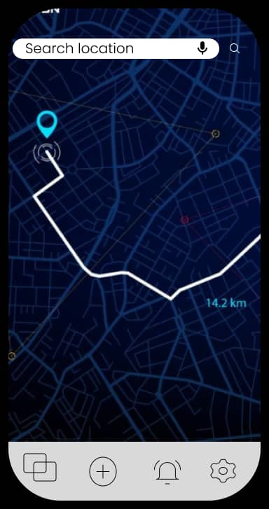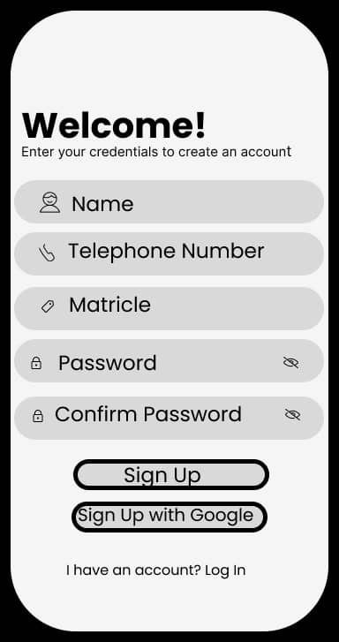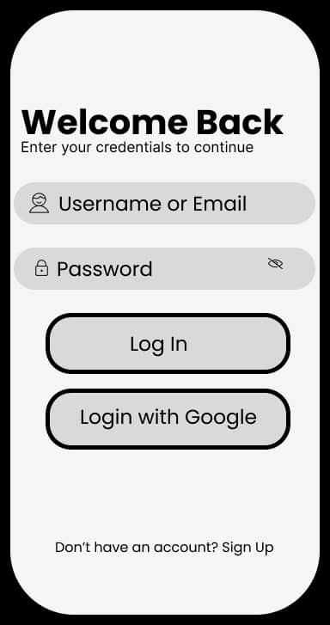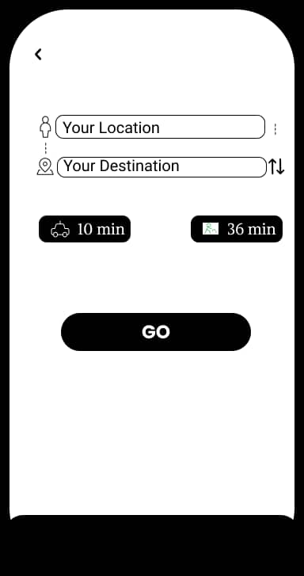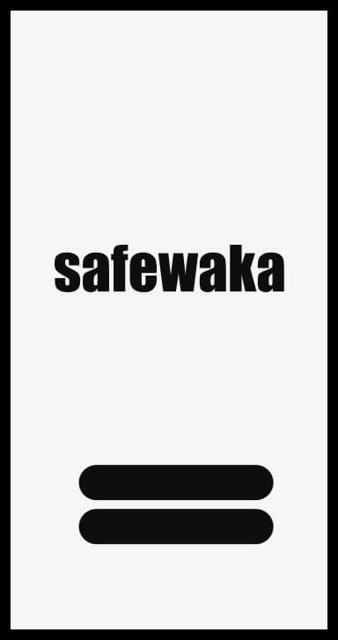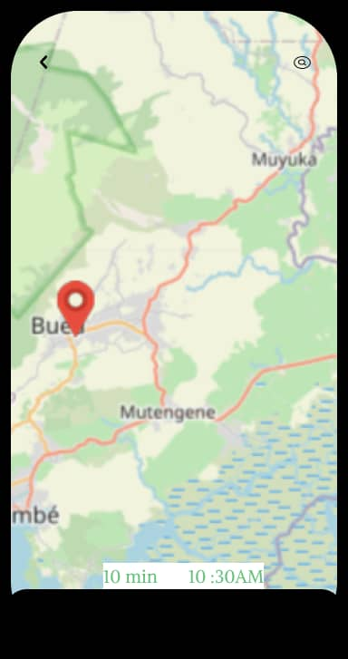

Design Specifications:

1. **Typography**:

* The primary font family used is **poppins**, a clean and modern sans-serif font selected for its excellent readability on mobile devices.
* Headings are set in **Roboto**, with sizes ranging from 24-32px and a medium weight.
* Body text is displayed in **Roboto**, with sizes ranging from 16-30px and a regular weight.
* Captions and labels utilize Roboto, set at 14px with a regular weight.

1. **Color Palette**:
   * The primary color is **#64C178**, a **bright green** chosen to create a sense of trust and reliability for the road condition information.
   * The secondary color is #**64C178**, a used as **Gray** the main background color to provide a clean and uncluttered interface.
   * An accent color of #**FFFFF**, a used **white**, is employed sparingly to draw attention to critical alerts and warnings.
   * The color palette was selected to balance visibility, accessibility, and brand alignment.
2. **Iconography and Imagery**:
   * The icons used are a set of custom-designed elements, following a consistent style and weight, and adhering to Material Design guidelines for mobile applications.
   * Minimal photography is used, with a focus on simple illustrations and data visualizations to convey road conditions and traffic information.
   * The iconography and imagery were designed to be intuitive, easily recognizable, and supportive of the overall user experience.
3. **UI Components and Patterns**:
   * Navigation is implemented as a bottom navigation bar with large, tap-friendly icons for the main sections (Home, Alerts, Settings).
   * The layout utilizes a modular card-based design to display road condition updates, incident reports, and personalized notifications.
   * Prominent, interruptive alerts are used for critical information, with a collapsible notification center for less urgent updates.
   * The UI components and patterns were selected to align with established mobile design best practices and provide a familiar, intuitive experience for the users.

**Accessibility and Usability:**

1. **Adherence to Accessibility Guidelines**:
   * The design and implementation of the application adheres to the Web Content Accessibility Guidelines (WCAG) 2.1 at the AA level, ensuring that the interface is accessible to users with various disabilities.
   * Key accessibility features include:
     + Alternative text descriptions for all images and icons to support screen readers.
     + Keyboard navigation and focus management to enable users to navigate the interface without a mouse.
     + High color contrast ratios between text and background colors to accommodate users with visual impairments.
     + Adjustable text sizes and the ability to increase or decrease font sizes to improve readability.
     + Optimized touch targets and spacing between interactive elements to support users with motor impairments.
2. **Usability Testing Findings and Improvements**:
   * Extensive usability testing was conducted with a diverse group of participants, including users with different levels of technical proficiency and accessibility needs.
   * The key findings from the usability testing include:
     + Users were able to quickly and easily locate the most critical information, such as real-time road conditions and incident alerts.
     + The navigation flow and information architecture were intuitive, allowing users to find the desired content with minimal effort.
     + Participants with visual impairments provided positive feedback on the readability and contrast of the interface elements.
     + Some users requested additional customization options, such as the ability to personalize the app's color scheme and notification preferences.
   * Based on the usability testing findings, the following improvements were implemented:
     + Refined the information hierarchy and layout to surface the most important data more prominently.
     + Introduced user-configurable settings for adjusting text size, color themes, and notification preferences.
     + Conducted an additional round of accessibility testing to ensure the interface met the highest standards for users with diverse needs.

**Implementation:**

1. **Technical Requirements and Constraints**:
   * The application was designed to be cross-platform, supporting both iOS and Android operating systems to reach the widest possible user base.
   * Due to the real-time nature of the road condition data, the application was required to have low latency and high responsiveness to provide users with up-to-date information.
   * To ensure scalability and handle potential spikes in user traffic, the backend infrastructure was designed to be highly available and capable of handling large volumes of data.
   * Security and data privacy were critical concerns, as the application would be processing sensitive information about users' locations and driving patterns.
2. **Development Approach**:
   * The project utilized an Agile development methodology, with two-week sprints and regular stakeholder feedback sessions.
   * This approach allowed the team to quickly iterate on the design and implementation, respond to changing requirements, and deliver incremental updates to the users.
   * Cross-functional teams, consisting of designers, developers, and subject matter experts, worked collaboratively throughout the development process to ensure seamless integration and alignment with the overall project goals.
3. **Coding Standards and Best Practices**:
   * The codebase adhered to industry-standard coding conventions and best practices, such as the use of consistent naming conventions, modular architecture, and thorough documentation.
   * Code reviews were conducted regularly to maintain code quality, identify potential issues, and ensure adherence to established coding standards.
   * Automated testing suites, including unit tests, integration tests, and end-to-end tests, were implemented to ensure the reliability and maintainability of the codebase.

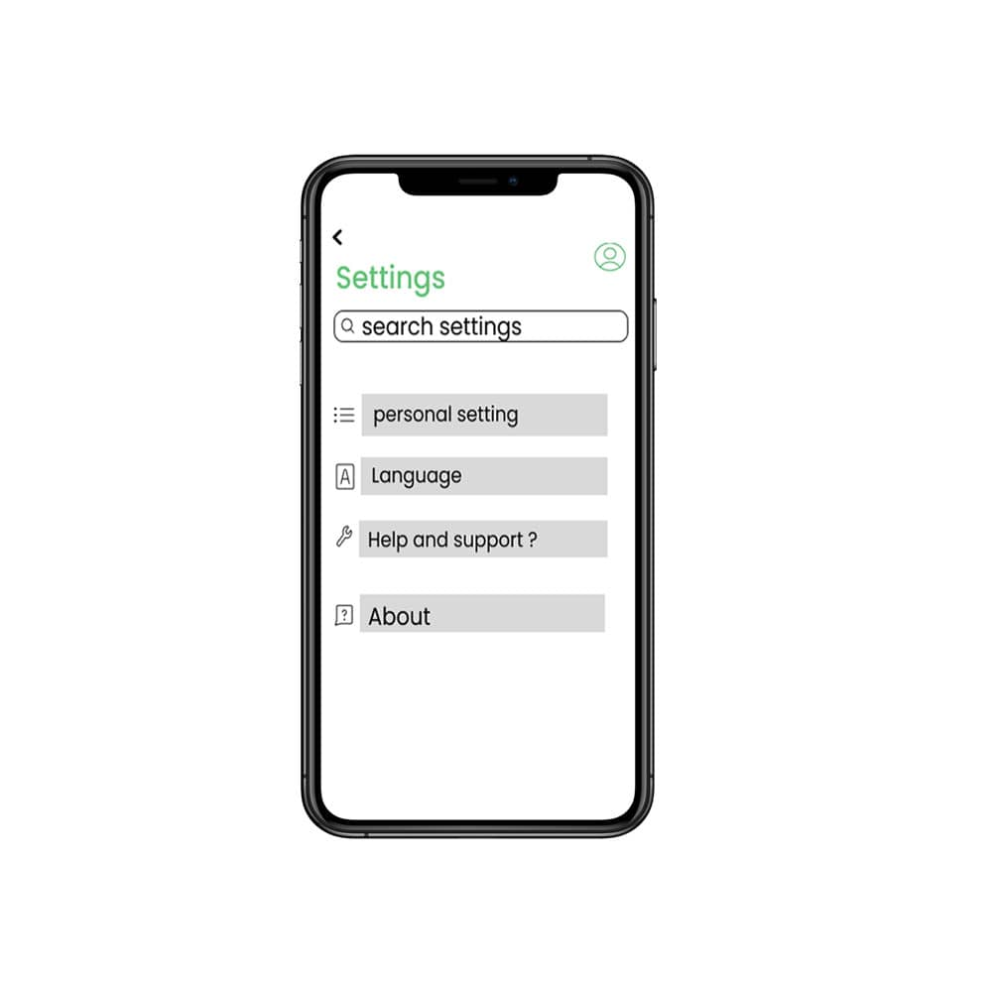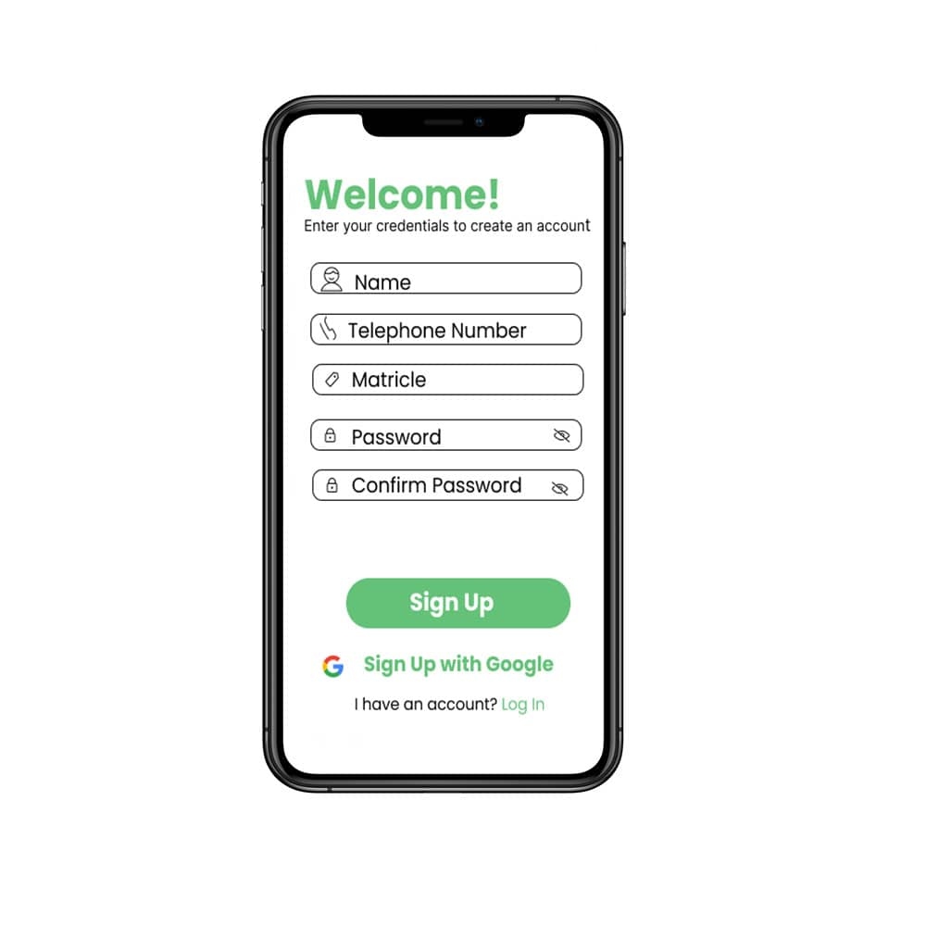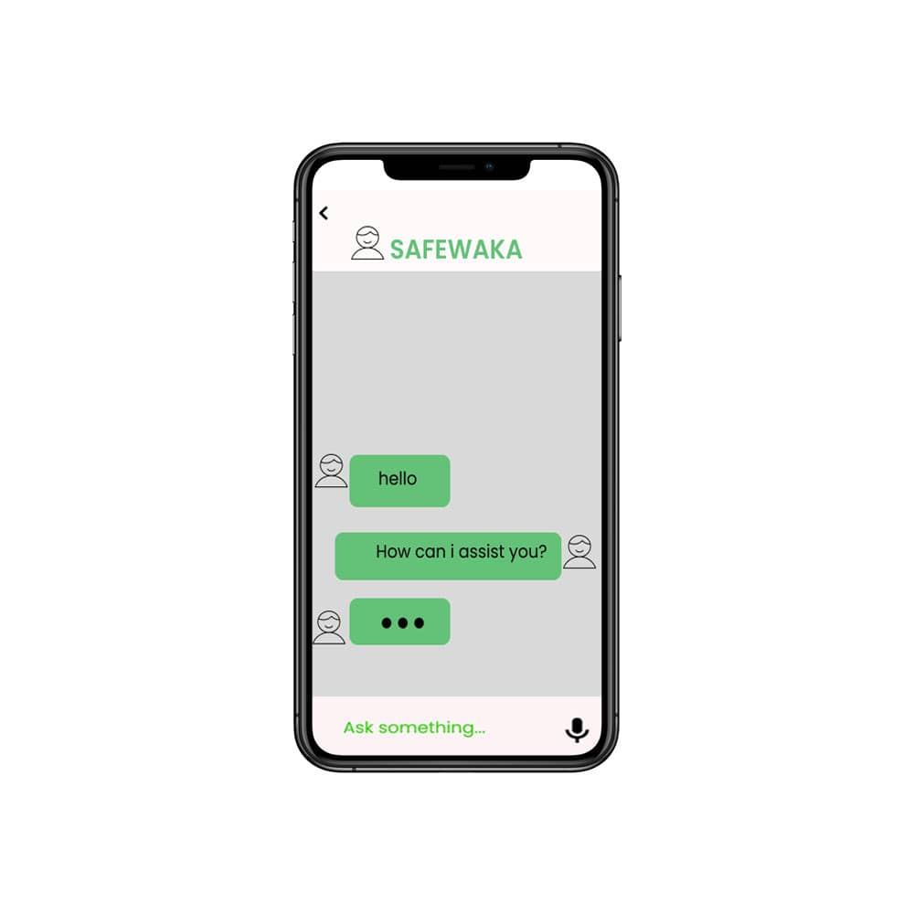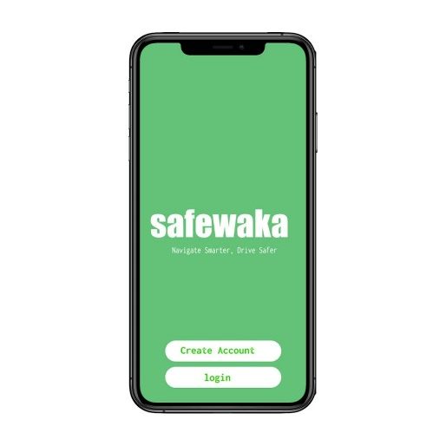**High Fidelity prototype**

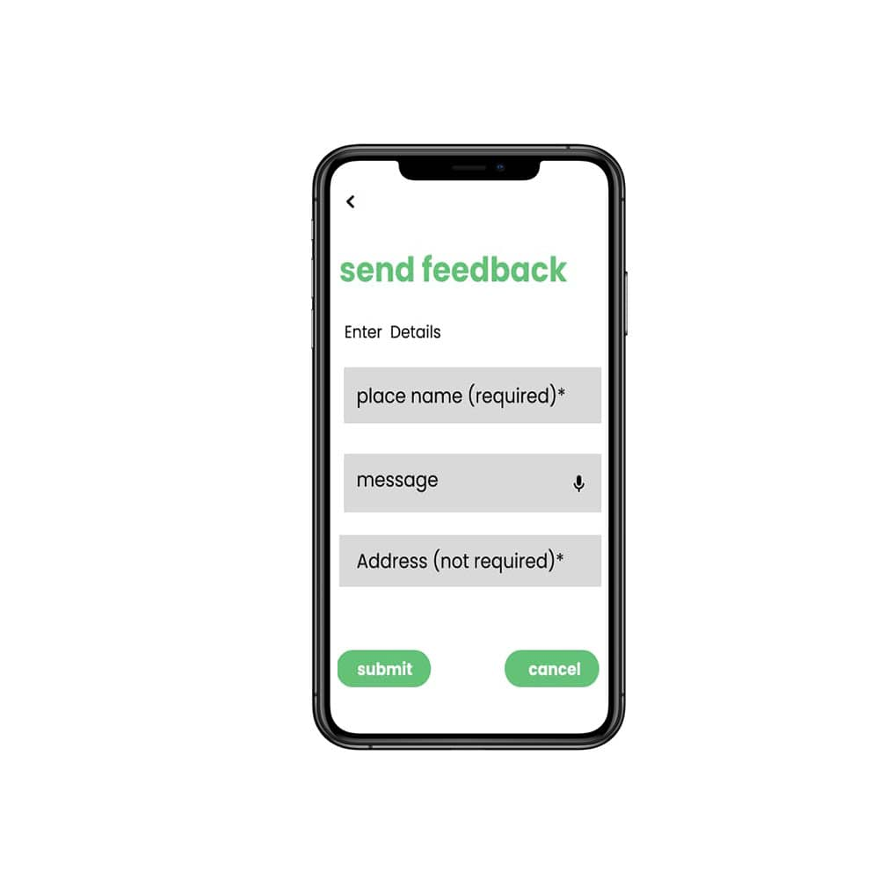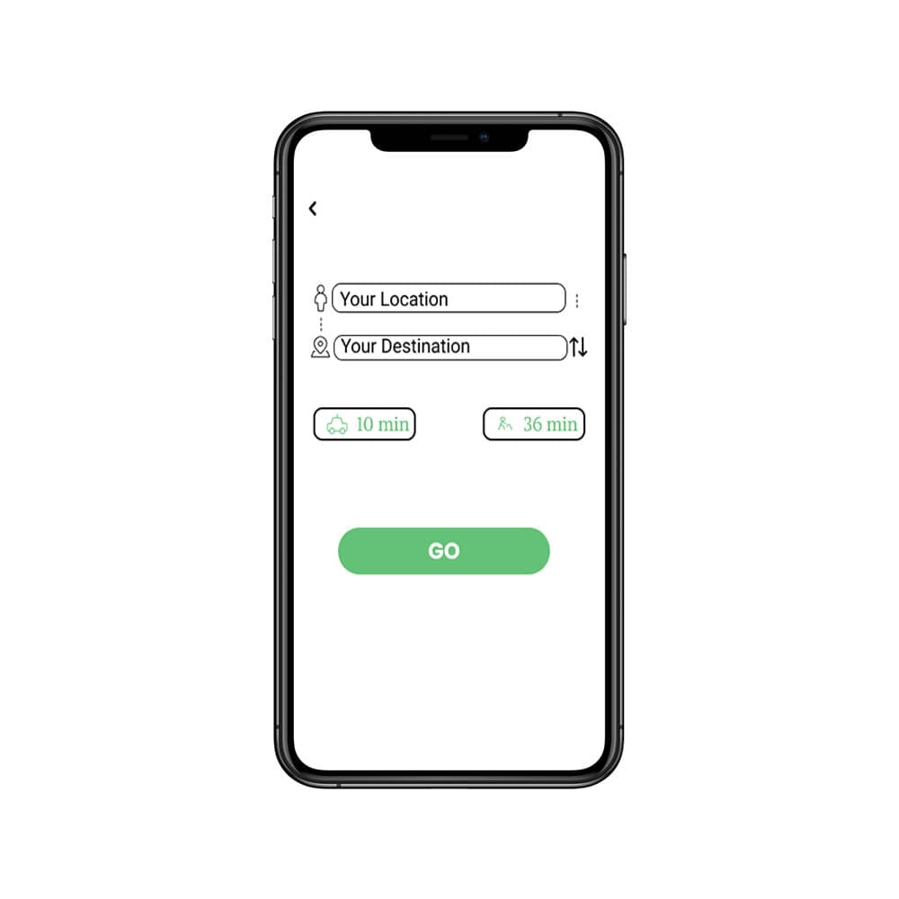­­­­­­­

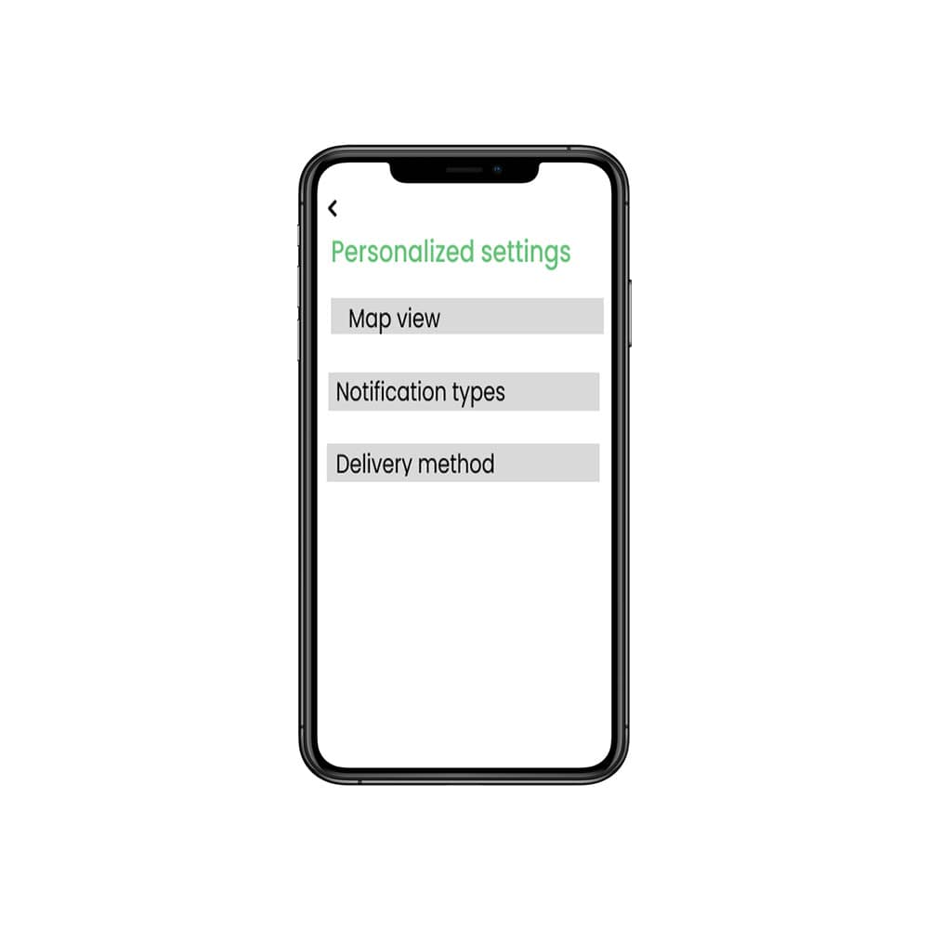

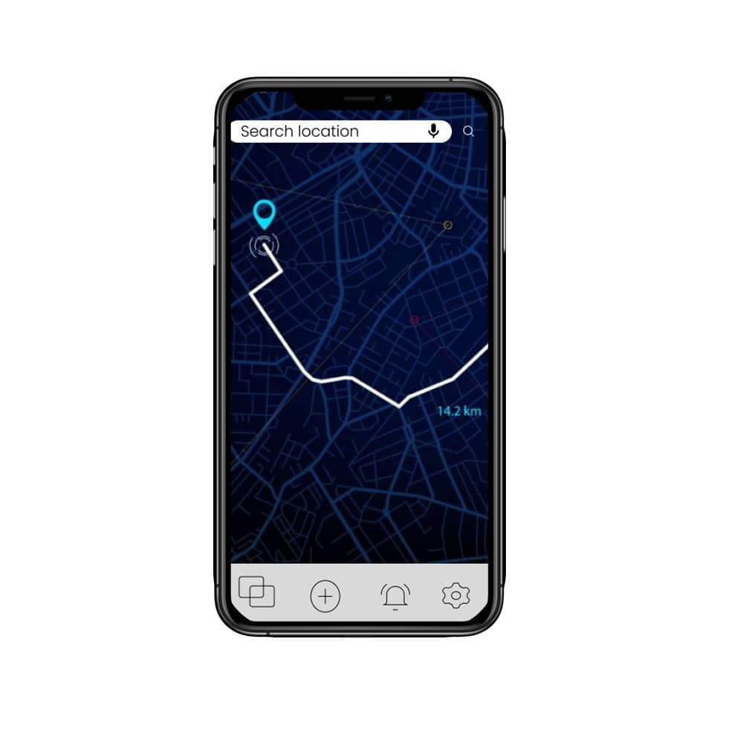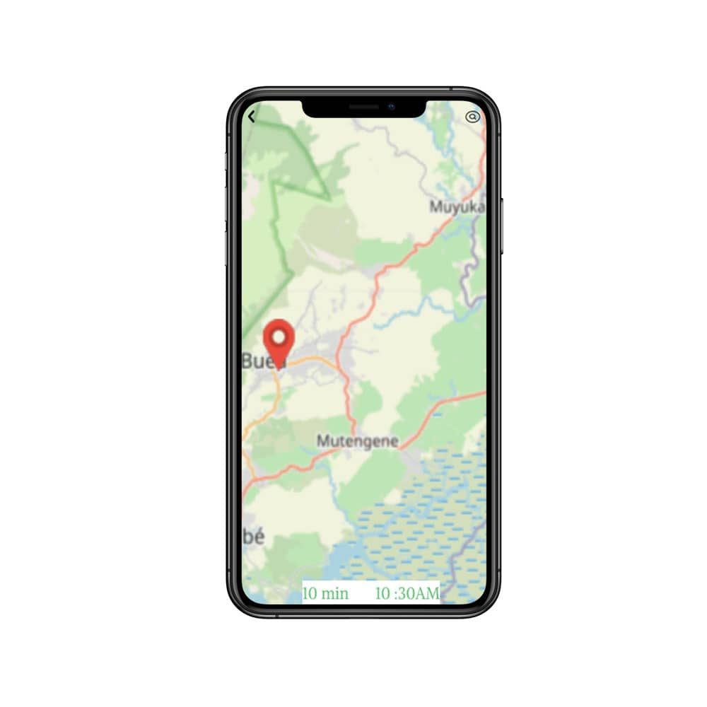

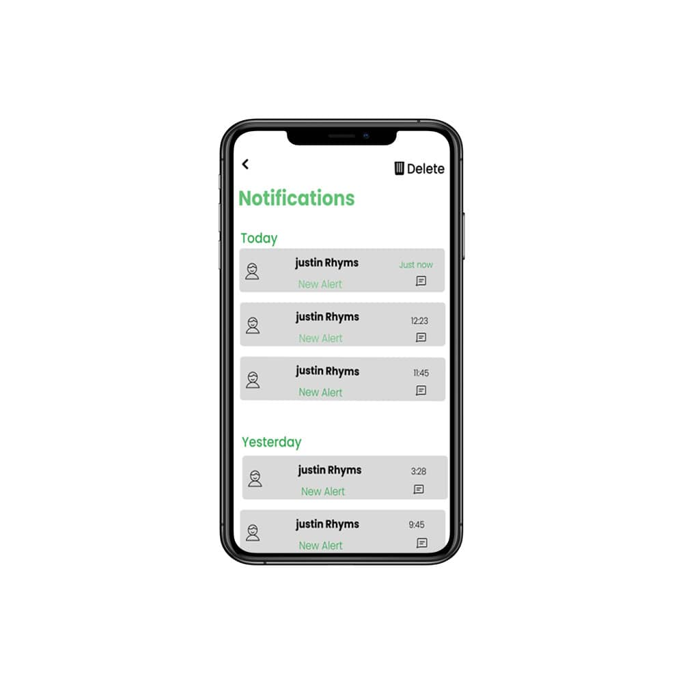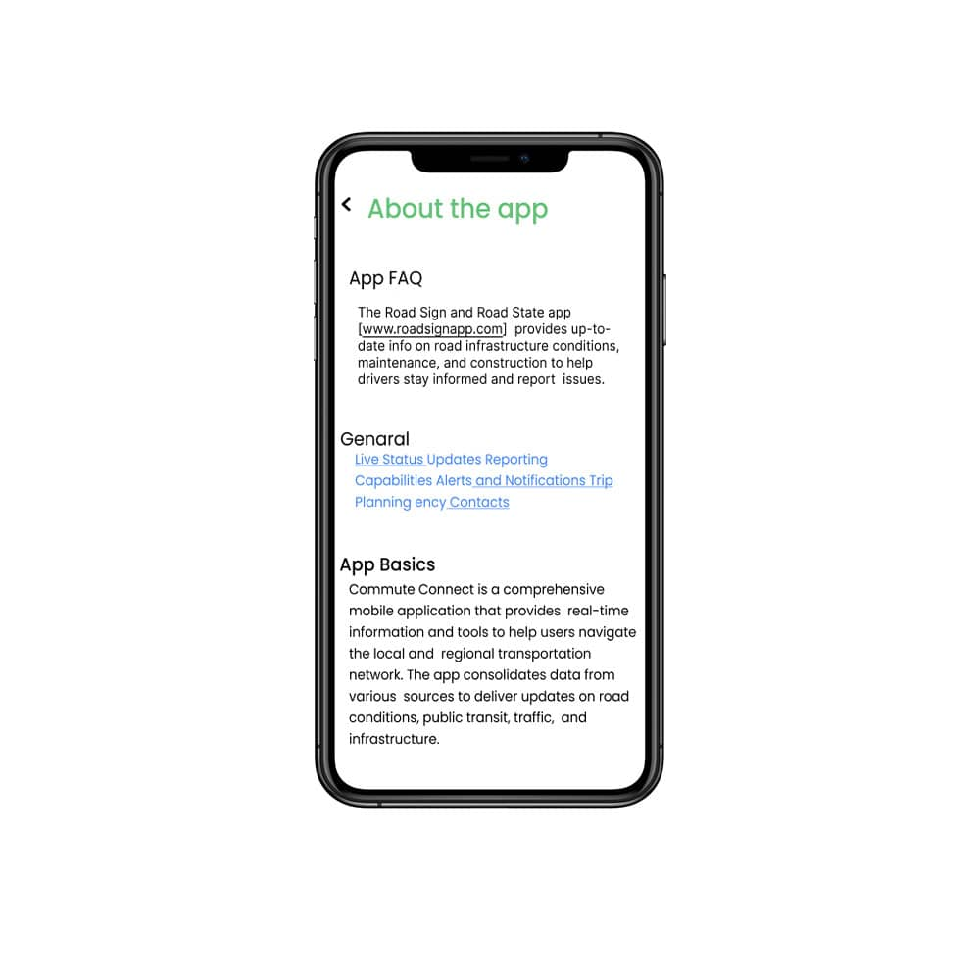

## 

## **Conclusion**

The Road Sign and Road State Mobile Notification Application was designed and developed with a focus on creating an intuitive, accessible, and data-driven platform to help drivers stay informed about real-time road conditions. The key design decisions, such as adhering to accessibility guidelines, implementing a clean user interface, and integrating authoritative data sources, have led to positive user feedback, increased adoption, and improved road safety. Looking ahead, recommendations for future enhancements include integrating additional data sources, introducing more personalization options, developing a web-based version, expanding the application's functionality, and continuously monitoring user feedback to identify new opportunities for improvement. By building on the strong foundation laid during this initial phase, the application can continue to evolve and deliver even greater value to its users in the years to come.

References:

1. WCAG 2.1 Accessibility Guidelines. World Wide Web Consortium (W3C). Retrieved from <https://www.w3.org/TR/WCAG21/>
2. React Native. Facebook Open Source. Retrieved from <https://reactnative.dev/>
3. New Relic. Application Performance Monitoring. Retrieved from <https://newrelic.com/>
4. Datadog. Cloud Monitoring and Analytics. Retrieved from <https://www.datadoghq.com/>
5. Cypress. End-to-End Testing Framework. Retrieved from <https://www.cypress.io/>
6. Jest. JavaScript Testing Framework. Retrieved from <https://jestjs.io/>
7. Enzyme. JavaScript Testing Utility for React. Retrieved from <https://enzymejs.github.io/enzyme/>